ASSIGNMENT NO.2

**1. Working with java.lang.Boolean**

**a.** Explore the [Java API documentation for java.lang.Boolean](https://docs.oracle.com/javase/8/docs/api/java/lang/Boolean.html) and observe its modifiers and super types.

**b.** Declare a method-local variable status of type boolean with the value true and convert it to a String using the toString method. (Hint: Use Boolean.toString(Boolean) ).

**package** org.example.demo;

**public** **class** Assignment2_1_1 {

**public** **static** **void** main(String args[]) {

**boolean** strstatus = **true**;

Boolean m = Boolean.*valueOf*(strstatus);

System.***out***.println(m);

}

}

**Output -**



**b.**Declare a method-local variable strStatus of type String with the value "true" and convert it to a boolean using the parseBoolean method. (Hint: Use Boolean.parseBoolean(String)).

**package** org.example.demo;

**public** **class** Assignment2_1_2 {

**public** **static** **void** main(String args[]) {

String strstatus = "true";

**boolean** number = Boolean.*parseBoolean*(strstatus);

System.***out***.println(number);

}

}

**Output -**



**d.** Declare a method-local variable strStatus of type String with the value "1" or "0" and attempt to convert it to a boolean. (Hint: parseBoolean method will not work as expected with "1" or "0").

**package** org.example.demo**;**

**public class** Assignment2_1_2 **{**

**public static void** main(String args[]) {

String strstatus = "true";

**boolean** number = Boolean.*parseBoolean*(strstatus);

System**.*out***.println(number);

**}**

**}**

**Output -**



**e.** Declare a method-local variable status of type boolean with the value true and convert it to the corresponding wrapper class using Boolean.valueOf(). (Hint: Use Boolean.valueOf(boolean)).

**package org.example.demo;**

**public class Assignment2_1_4 {**

**public static void main(String args[]) {**

**boolean status = true;**

**System.*out*.println(Boolean.*valueOf*(status));**

**}**

**}**

**Output -**



**f.** Declare a method-local variable strStatus of type String with the value "true" and convert it to the corresponding wrapper class using Boolean.valueOf(). (Hint: Use Boolean.valueOf(String)).

**package org.example.demo;**

**public class Assignment2_1_5 {**

**public static void main(String args[]) {**

**boolean strstatus = true;**

**Boolean number = Boolean.*valueOf*(strstatus);**

**System.*out*.println(number);**

**}**

**}**

**Output -**



**g.** Experiment with converting a boolean value into other primitive types or vice versa and observe the results.

**package org.example.demo;**

**public class Assignment2_1_6 {**

**public static void main(String[] args) {**

**boolean flag = true;**

**String boolToString = Boolean.*toString*(flag);**

**System.*out*.println("Boolean to String: " + boolToString);**

**String str = "true";**

**boolean stringToBool = Boolean.*parseBoolean*(str);**

**System.*out*.println("String to Boolean: " + stringToBool);**

**int boolToInt = flag ? 1 : 0;**

**System.*out*.println("Boolean to int: " + boolToInt);**

**int num = 5;**

**boolean intToBool = (num != 0);**

**System.*out*.println("int to Boolean: " + intToBool);**

**}**

**}**

**Output –**

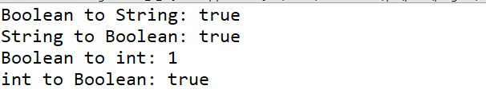

**2. Working with java.lang.Byte**

**a.** Explore the [Java API documentation for java.lang.Byte](https://docs.oracle.com/javase/8/docs/api/java/lang/Byte.html) and observe its modifiers and super types.

**b.** Write a program to test how many bytes are used to represent a byte value using the BYTES field. (Hint: Use Byte.BYTES).

**package org.example.demo;**

**public class Assignment2_2_1 {**

**public static void main(String args[]) {**

**System.*out*.println( "Number of bytes used to represent a byte: " + Byte.*BYTES*);**

**}**

**}**

**Output –**



**c.** Write a program to find the minimum and maximum values of byte using the MIN_VALUE and MAX_VALUE fields. (Hint: Use Byte.MIN_VALUE and Byte.MAX_VALUE).

**package org.example.demo;**

**public class Assignment2_2_2 {**

**public static void main(String args[]) {**

**System.*out*.println("Minimum value of byte: " + Byte.*MIN_VALUE*);**

**System.*out*.println("Maximum value of byte: " + Byte.*MAX_VALUE*);**

**}**

**}**

**Output –**

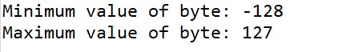

**d.** Declare a method-local variable number of type byte with some value and convert it to a String using the toString method. (Hint: Use Byte.toString(byte)).

**package org.example.demo;**

**public class Assignment2_2_3 {**

**public static void main(String args[]) {**

**byte n = 12;**

**String m = Byte.*toString*(n);**

**System.*out*.println(m);**

**}**

**}**

**Output –**



**e.** Declare a method-local variable strNumber of type String with some value and convert it to a byte value using the parseByte method. (Hint: Use Byte.parseByte(String)).

**package org.example.demo;**

**public class Assignment2_2_4 {**

**public static void main(String[] args) {**

**// TODO Auto-generated method stub**

**String strNumber = "123";**

**byte m = Byte.*parseByte*(strNumber);**

**System.*out*.println(m);**

**}**

**}**

**Output –**



**f.** Declare a method-local variable strNumber of type String with the value "Ab12Cd3" and attempt to convert it to a byte value. (Hint: parseByte method will throw a NumberFormatException).

**package org.example.demo;**

**public class Assignment2_2_5 {**

**public static void main(String[] args) {**

**// TODO Auto-generated method stub**

**String strNumber = "Ab12Cd3";**

**byte m = Byte.*parseByte*(strNumber);**

**System.*out*.println(m);**

**}**

**}**

**Output –**

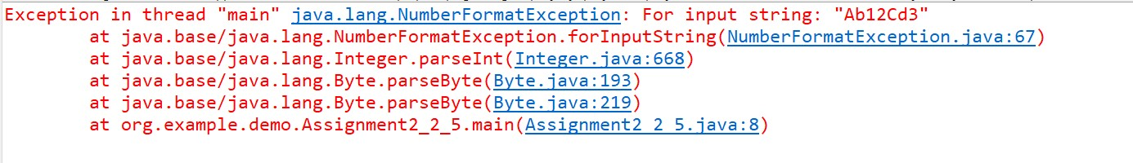

**g.** Declare a method-local variable number of type byte with some value and convert it to the corresponding wrapper class using Byte.valueOf(). (Hint: Use Byte.valueOf(byte)).

**package org.example.demo;**

**public class Assignment2_2_5 {**

**public static void main(String[] args) {**

**// TODO Auto-generated method stub**

**String strNumber = "Ab12Cd3";**

**byte m = Byte.*parseByte*(strNumber);**

**System.*out*.println(m);**

**}**

**}**

**Output –**



**h.** Declare a method-local variable strNumber of type String with some byte value and convert it to the corresponding wrapper class using Byte.valueOf(). (Hint: Use Byte.valueOf(String)).

**package org.example.demo;**

**public class Assignment2_2_7 {**

**public static void main(String args[]) {**

**String strNumber = "123";**

**byte m = Byte.*valueOf*(strNumber);**

**System.*out*.println(m);**

**}**

**}**

**Output –**



**i.** Experiment with converting a byte value into other primitive types or vice versa and observe the results.

**package org.example.demo;**

**public class Assignment2_2_8 {**

**public static void main(String[] args) {**

**byte b = 10;**

**// Convert byte to int**

**int intValue = b;**

**System.*out*.println("Byte to int: " + intValue);**

**// Convert byte to short**

**short shortValue = b;**

**System.*out*.println("Byte to short: " + shortValue);**

**// Convert byte to long**

**long longValue = b;**

**System.*out*.println("Byte to long: " + longValue);**

**// Convert byte to float**

**float floatValue = b;**

**System.*out*.println("Byte to float: " + floatValue);**

**// Convert byte to double**

**double doubleValue = b;**

**System.*out*.println("Byte to double: " + doubleValue);**

**// Convert byte to char (explicit casting needed)**

**char charValue = (char) b;**

**System.*out*.println("Byte to char: " + charValue);**

**// Convert int to byte (explicit casting needed)**

**int someInt = 130;**

**byte byteFromInt = (byte) someInt;**

**System.*out*.println("Int to byte (130 -> overflow): " + byteFromInt);**

**// Convert double to byte (explicit casting needed)**

**double someDouble = 15.67;**

**byte byteFromDouble = (byte) someDouble;**

**System.*out*.println("Double to byte (15.67 -> truncated): " + byteFromDouble);**

**}**

**}**

**Output –**

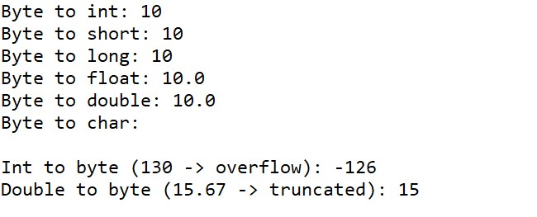

**3. Working with java.lang.Short**

**a.** Explore the [Java API documentation for java.lang.Short](https://docs.oracle.com/javase/8/docs/api/java/lang/Short.html) and observe its modifiers and super types.

**b.** Write a program to test how many bytes are used to represent a short value using the BYTES field. (Hint: Use Short.BYTES).

**package org.example.demo;**

**public class Assignment2_3_1 {**

**public static void main(String[] args) {**

**// TODO Auto-generated method stub**

**System.*out*.println(Short.*BYTES*);**

**}**

**}**

**Output –**



**c.** Write a program to find the minimum and maximum values of short using the MIN_VALUE and MAX_VALUE fields. (Hint: Use Short.MIN_VALUE and Short.MAX_VALUE).

**package org.example.demo;**

**public class Assignment2_3_2 {**

**public static void main(String[] args) {**

**// TODO Auto-generated method stub**

**System.*out*.println(Short.*MIN_VALUE*);**

**System.*out*.println(Short.*MAX_VALUE*);**

**}**

**}**

**Output –**



**d.** Declare a method-local variable number of type short with some value and convert it to a String using the toString method. (Hint: Use Short.toString(short)).

**package org.example.demo;**

**public class Assignment2_3_3 {**

**public static void main(String[] args) {**

**// TODO Auto-generated method stub**

**short number = 3276;**

**String str = Short.*toString*(number);**

**System.*out*.println(str);**

**}**

**}**

**Output –**



**e.** Declare a method-local variable strNumber of type String with some value and convert it to a short value using the parseShort method. (Hint: Use Short.parseShort(String)).

**package org.example.demo;**

**public class Assignment2_3_4 {**

**public static void main(String[] args) {**

**// TODO Auto-generated method stub**

**String strnumber = "1243";**

**short number = Short.*parseShort*(strnumber);**

**System.*out*.println(number);**

**}**

**}**

**Output –**



**f.** Declare a method-local variable strNumber of type String with the value "Ab12Cd3" and attempt to convert it to a short value. (Hint: parseShort method will throw a NumberFormatException).

**package org.example.demo;**

**public class Assignment2_3_5 {**

**public static void main(String[] args) {**

**// TODO Auto-generated method stub**

**String strNumber = "Ab12Cd3";**

**short number = Short.*parseShort*(strNumber);**

**System.*out*.println(number);**

**}**

**}**

**Output –**

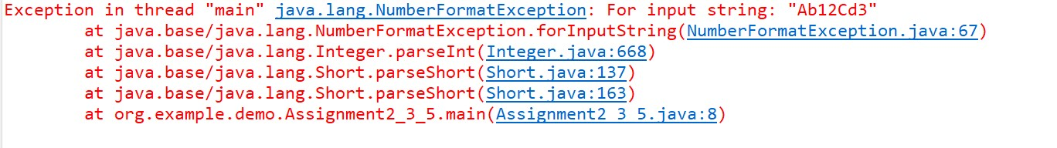

**g.** Declare a method-local variable number of type short with some value and convert it to the corresponding wrapper class using Short.valueOf(). (Hint: Use Short.valueOf(short)).

**package org.example.demo;**

**public class Assignment2_3_6 {**

**public static void main(String args[]) {**

**short number = 23;**

**System.*out*.println(number);**

**Short wrapperclass = Short.*valueOf*(number);**

**System.*out*.println(wrapperclass);**

**}**

**}**

**Output –**



**h.** Declare a method-local variable strNumber of type String with some short value and convert it to the corresponding wrapper class using Short.valueOf(). (Hint: Use Short.valueOf(String)).

**package org.example.demo;**

**public class Assignment2_3_7 {**

**public static void main(String[] args) {**

**// TODO Auto-generated method stub**

**String strNumber = "2345";**

**Short number = Short.*valueOf*(strNumber);**

**System.*out*.println(number);**

**}**

**}**

**Output –**



**i.** Experiment with converting a short value into other primitive types or vice versa and observe the results.

**package org.example.demo;**

**public class Assignment2_3_8 {**

**public static void main(String[] args) {**

**// TODO Auto-generated method stub**

**short number = 123;**

**String strnumber = Short.*toString*(number);**

**System.*out*.println(strnumber);**

**int innum = (int) number;**

**System.*out*.println(innum);**

**double num = number;**

**System.*out*.println(num);**

**float n = number;**

**System.*out*.println(n);**

**byte s = (byte) number;**

**System.*out*.println(s);**

**}**

**}**

**Output –**



**Output –**

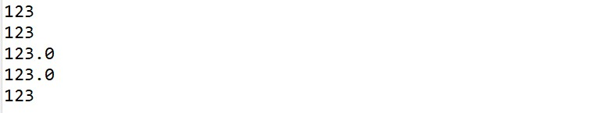

**4. Working with java.lang.Integer**

**a.** Explore the [Java API documentation for java.lang.Integer](https://docs.oracle.com/javase/8/docs/api/java/lang/Integer.html) and observe its modifiers and super types.

**b.** Write a program to test how many bytes are used to represent an int value using the BYTES field. (Hint: Use Integer.BYTES).

**package org.example.demo;**

**public class Assignment2_4_1 {**

**public static void main(String[] args) {**

**// TODO Auto-generated method stub**

**System.*out*.println(Integer.*BYTES*);**

**}**

**}**

**Output –**



**c.** Write a program to find the minimum and maximum values of int using the MIN_VALUE and MAX_VALUE fields. (Hint: Use Integer.MIN_VALUE and Integer.MAX_VALUE).

**package org.example.demo;**

**public class Assignment2_4_2 {**

**public static void main(String[] args) {**

**// TODO Auto-generated method stub**

**System.*out*.println(Integer.*MIN_VALUE*);**

**System.*out*.println(Integer.*MAX_VALUE*);**

**}**

**}**

**Output –**

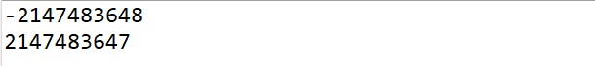

**d.** Declare a method-local variable number of type int with some value and convert it to a String using the toString method. (Hint: Use Integer.toString(int)).

**package org.example.demo;**

**public class Assignment2_4_3 {**

**public static void main(String[] args) {**

**// TODO Auto-generated method stub**

**int number = 45;**

**String strnumber = Integer.*toString*(number);**

**System.*out*.println(strnumber);**

**}**

**}**

**Output –**



**e.** Declare a method-local variable strNumber of type String with some value and convert it to an int value using the parseInt method. (Hint: Use Integer.parseInt(String)).

**package org.example.demo;**

**public class Assignment2_4_4 {**

**public static void main(String[] args) {**

**// TODO Auto-generated method stub**

**String strnumber = "123443";**

**int number = Integer.*parseInt*(strnumber);**

**System.*out*.println(number);**

**}**

**}**

**Output –**



**f.** Declare a method-local variable strNumber of type String with the value "Ab12Cd3" and attempt to convert it to an int value. (Hint: parseInt method will throw a NumberFormatException).

**package org.example.demo;**

**public class Assignment2_4_5 {**

**public static void main(String[] args) {**

**// TODO Auto-generated method stub**

**String strnumber = "Ab12Cd3";**

**int number = Integer.*parseInt*(strnumber);**

**System.*out*.println(number);**

**}**

**}**

**Output –**

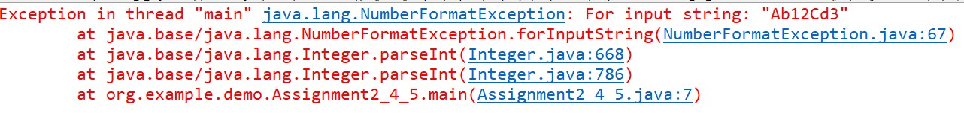

**g.** Declare a method-local variable number of type int with some value and convert it to the corresponding wrapper class using Integer.valueOf(). (Hint: Use Integer.valueOf(int)).

**package org.example.demo;**

**public class Assignment2_4_6 {**

**public static void main(String[] args) {**

**// TODO Auto-generated method stub**

**int number = 1234;**

**Integer n = Integer.*valueOf*(number);**

**System.*out*.println(n);**

**}**

**}**

**Output –**



**h.** Declare a method-local variable strNumber of type String with some integer value and convert it to the corresponding wrapper class using Integer.valueOf(). (Hint: Use Integer.valueOf(String)).

**package org.example.demo;**

**public class Assignment2_4_7 {**

**public static void main(String[] args) {**

**// TODO Auto-generated method stub**

**String strnumber = "351234";**

**Integer n = Integer.*valueOf*(strnumber);**

**System.*out*.println(n);**

**}**

**}**

**Output –**



**i.** Declare two integer variables with values 10 and 20, and add them using a method from the Integer class. (Hint: Use Integer.sum(int, int)).

**package org.example.demo;**

**public class Assignment2_4_8 {**

**public static void main(String[] args) {**

**// TODO Auto-generated method stub**

**int num1 = 12;**

**System.*out*.println("value of num1 :" +num1);**

**int num2 = 20;**

**System.*out*.println("value of num2 :" +num2);**

**int sum = Integer.*sum*(num1, num2);**

**System.*out*.println("sum of two numbers is : " +sum);**

**}**

**}**

**Output –**

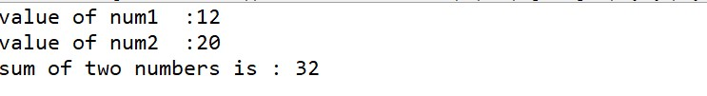

**j.** Declare two integer variables with values 10 and 20, and find the minimum and maximum values using the Integer class. (Hint: Use Integer.min(int, int) and Integer.max(int, int)).

**package org.example.demo;**

**public class Assignment2_4_9 {**

**public static void main(String[] args) {**

**// TODO Auto-generated method stub**

**int num1 = 10;**

**System.*out*.println("value of num1 :" +num1);**

**int num2 = 20;**

**System.*out*.println("value of num2 :" +num2);**

**System.*out*.println(Integer.*min*(num1,num2));**

**System.*out*.println(Integer.*max*(num1,num2));**

**}**

**}**

**Output –**

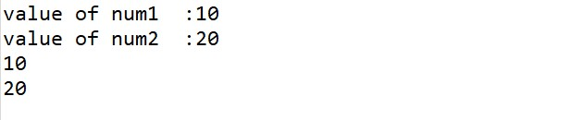

**k.** Declare an integer variable with the value 7. Convert it to binary, octal, and hexadecimal strings using methods from the Integer class. (Hint: Use Integer.toBinaryString(int), Integer.toOctalString(int), and Integer.toHexString(int)).

**package org.example.demo;**

**public class Assignment2_4_10 {**

**public static void main(String[] args) {**

**// TODO Auto-generated method stub**

**int number = 7;**

**System.*out*.println(Integer.*toBinaryString*(number));**

**System.*out*.println(Integer.*toOctalString*(number));**

**System.*out*.println(Integer.*toHexString*(number));**

**}**

**}**

**Output –**

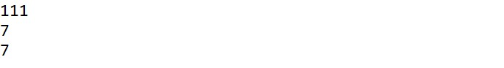

**l.** Experiment with converting an int value into other primitive types or vice versa and observe the results.

**package org.example.demo;**

**public class Assignment2_4_11 {**

**public static void main(String[] args) {**

**int b = 10;**

**// Convert byte to int**

**int byteValue = (byte) b;**

**System.*out*.println("int to byte: " + byteValue);**

**// Convert byte to short**

**short shortValue = (short)b;**

**System.*out*.println("int to short: " + shortValue);**

**// Convert byte to long**

**long longValue = b;**

**System.*out*.println("int to long: " + longValue);**

**// Convert byte to float**

**float floatValue = b;**

**System.*out*.println("int to float: " + floatValue);**

**// Convert byte to double**

**double doubleValue = b;**

**System.*out*.println("int to double: " + doubleValue);**

**}**

**}**

**Output –**

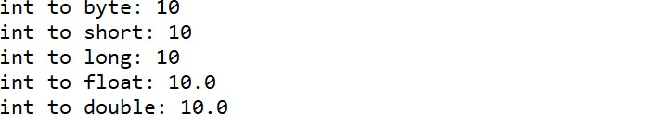

**5. Working with java.lang.Long**

**a.** Explore the [Java API documentation for java.lang.Long](https://docs.oracle.com/javase/8/docs/api/java/lang/Long.html) and observe its modifiers and super types.

**b.** Write a program to test how many bytes are used to represent a long value using the BYTES field. (Hint: Use Long.BYTES).

**package org.example.demo;**

**public class Assignment2_5_1 {**

**public static void main(String[] args) {**

**// TODO Auto-generated method stub**

**System.*out*.println(Long.*BYTES*);**

**}**

**}**

**Output –**



**c.** Write a program to find the minimum and maximum values of long using the MIN_VALUE and MAX_VALUE fields. (Hint: Use Long.MIN_VALUE and Long.MAX_VALUE).

**package org.example.demo;**

**public class Assignment2_5_2 {**

**public static void main(String[] args) {**

**// TODO Auto-generated method stub**

**System.*out*.println(Long.*MIN_VALUE*);**

**System.*out*.println(Long.*MAX_VALUE*);**

**}**

**}**

**Output –**



**d.** Declare a method-local variable number of type long with some value and convert it to a String using the toString method. (Hint: Use Long.toString(long)).

**package org.example.demo;**

**public class Assignment2_5_3 {**

**public static void main(String[] args) {**

**// TODO Auto-generated method stub**

**long number = 123456;**

**String m = Long.*toString*(number);**

**System.*out*.println(m);**

**}**

**}**

**Output –**



**e.** Declare a method-local variable strNumber of type String with some value and convert it to a long value using the parseLong method. (Hint: Use Long.parseLong(String)).

**package org.example.demo;**

**public class Assignment2_5_4 {**

**public static void main(String[] args) {**

**// TODO Auto-generated method stub**

**String strnumber = "124356";**

**long num = Long.*parseLong*(strnumber);**

**System.*out*.println(num);**

**}**

**}**

**Output –**



**f.** Declare a method-local variable strNumber of type String with the value "Ab12Cd3" and attempt to convert it to a long value. (Hint: parseLong method will throw a NumberFormatException).

**package org.example.demo;**

**public class Assignment2_5_5 {**

**public static void main(String[] args) {**

**// TODO Auto-generated method stub**

**String strnumber = "Ab12Cd3";**

**long num = Long.*parseLong*(strnumber);**

**System.*out*.println(num);**

**}**

**}**

**Output –**

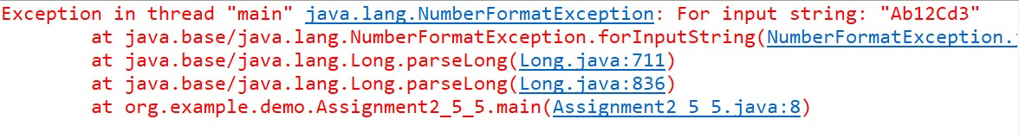

**g.** Declare a method-local variable number of type long with some value and convert it to the corresponding wrapper class using Long.valueOf(). (Hint: Use Long.valueOf(long)).

**package org.example.demo;**

**public class Assignment2_5_6 {**

**public static void main(String[] args) {**

**// TODO Auto-generated method stub**

**long number = 12345;**

**System.*out*.println(Long.*valueOf*(number));**

**}**

**}**

**Output –**



**h.** Declare a method-local variable strNumber of type String with some long value and convert it to the corresponding wrapper class using Long.valueOf(). (Hint: Use Long.valueOf(String)).

**package org.example.demo;**

**public class Assignment2_5_7 {**

**public static void main(String[] args) {**

**// TODO Auto-generated method stub**

**String strnumber = "12345";**

**System.*out*.println(Long.*valueOf*(strnumber));**

**}**

**}**

**Output –**



**i.** Declare two long variables with values 1123 and 9845, and add them using a method from the Long class. (Hint: Use Long.sum(long, long)).

**package org.example.demo;**

**public class Assignment2_5_8 {**

**public static void main(String[] args) {**

**// TODO Auto-generated method stub**

**long num1 = 1123;**

**long num2 = 9845;**

**System.*out*.println(Long.*sum*(num1, num2));**

**}**

**}**

**Output –**



**j.** Declare two long variables with values 1122 and 5566, and find the minimum and maximum values using the Long class. (Hint: Use Long.min(long, long) and Long.max(long, long)).

**package org.example.demo;**

**public class Assignment2_5_9 {**

**public static void main(String[] args) {**

**// TODO Auto-generated method stub**

**long num1 = 1122;**

**long num2 = 5566;**

**System.*out*.println("min : " +Long.*min*(num1, num2));**

**System.*out*.println("max : " +Long.*max*(num1, num2));**

**}**

**}**

**Output –**

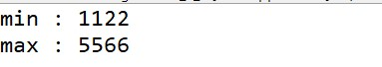

**k.** Declare a long variable with the value 7. Convert it to binary, octal, and hexadecimal strings using methods from the Long class. (Hint: Use Long.toBinaryString(long), Long.toOctalString(long), and Long.toHexString(long)).

**package org.example.demo;**

**public class Assignment2_5_10 {**

**public static void main(String[] args) {**

**// TODO Auto-generated method stub**

**long number = 7;**

**System.*out*.println(Long.*toBinaryString*(number));**

**System.*out*.println(Long.*toOctalString*(number));**

**System.*out*.println(Long.*toHexString*(number));**

**}**

**}**

**Output –**

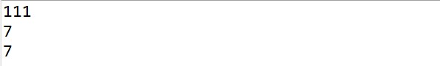

**l.** Experiment with converting a long value into other primitive types or vice versa and observe the results.

**package org.example.demo;**

**public class Assignment2_5_11 {**

**public static void main(String[] args) {**

**// TODO Auto-generated method stub**

**long number = 12345;**

**int n = (int) number;**

**System.*out*.println(n);**

**short m = (short) number;**

**System.*out*.println(m);**

**byte b = (byte) number;**

**System.*out*.println(b);**

**double d = (double) number;**

**System.*out*.println(d);**

**}**

**}**

**Output –**

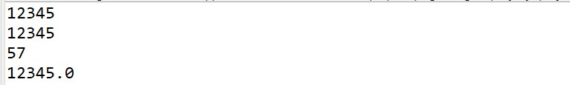

**6. Working with java.lang.Float**

**a.** Explore the [Java API documentation for java.lang.Float](https://docs.oracle.com/javase/8/docs/api/java/lang/Float.html) and observe its modifiers and super types.

**b.** Write a program to test how many bytes are used to represent a float value using the BYTES field. (Hint: Use Float.BYTES).

**package org.example.demo;**

**public class Assignment2_6_1 {**

**public static void main(String[] args) {**

**// TODO Auto-generated method stub**

**System.*out*.println(Float.*BYTES*);**

**}**

**}**

**Output –**



**c.** Write a program to find the minimum and maximum values of float using the MIN_VALUE and MAX_VALUE fields. (Hint: Use Float.MIN_VALUE and Float.MAX_VALUE).

**package org.example.demo;**

**public class Assignment2_6_2 {**

**public static void main(String args[]) {**

**System.*out*.println(Float.*MIN_VALUE*);**

**System.*out*.println(Float.*MAX_VALUE*);**

**}**

**}**

**Output –**

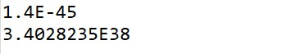

**d.** Declare a method-local variable number of type float with some value and convert it to a String using the toString method. (Hint: Use Float.toString(float)).

**package org.example.demo;**

**public class Assignment2_6_3 {**

**public static void main(String[] args) {**

**// TODO Auto-generated method stub**

**float number = 23.56f;**

**String strnumber = Float.*toString*(number);**

**System.*out*.println(strnumber);**

**}**

**}**

**Output –**



**e.** Declare a method-local variable strNumber of type String with some value and convert it to a float value using the parseFloat method. (Hint: Use Float.parseFloat(String)).

**package org.example.demo;**

**public class Assignment2_6_4 {**

**public static void main(String[] args) {**

**// TODO Auto-generated method stub**

**String strnumber = "123456";**

**float number = Float.*parseFloat*(strnumber);**

**System.*out*.println(number);**

**}**

**}**

**Output –**





**f.** Declare a method-local variable strNumber of type String with the value "Ab12Cd3" and attempt to convert it to a float value. (Hint: parseFloat method will throw a NumberFormatException).

**package org.example.demo;**

**public class Assignment2_6_5 {**

**public static void main(String[] args) {**

**// TODO Auto-generated method stub**

**String strnumber = "Ab12Cd3";**

**float number = Float.*parseFloat*(strnumber);**

**System.*out*.println(number);**

**}**

**}**

**Output –**

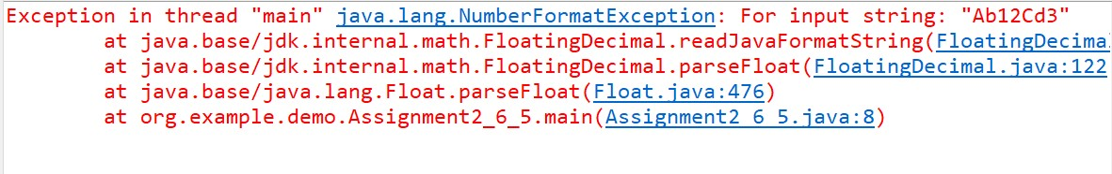

**g.** Declare a method-local variable number of type float with some value and convert it to the corresponding wrapper class using Float.valueOf(). (Hint: Use Float.valueOf(float)).

**package org.example.demo;**

**public class Assignment2_6_6 {**

**public static void main(String[] args) {**

**// TODO Auto-generated method stub**

**float number = 123456;**

**System.*out*.println(Float.*valueOf*(number));**

**}**

**}**

**Output –**



**h.** Declare a method-local variable strNumber of type String with some float value and convert it to the corresponding wrapper class using Float.valueOf(). (Hint: Use Float.valueOf(String)).

**package org.example.demo;**

**public class Assignment2_6_7 {**

**public static void main(String[] args) {**

**// TODO Auto-generated method stub**

**String strnumber = "123456";**

**System.*out*.println(Float.*valueOf*(strnumber));**

**}**

**}**

**Output –**



**i.** Declare two float variables with values 112.3 and 984.5, and add them using a method from the Float class. (Hint: Use Float.sum(float, float)).

**package org.example.demo;**

**public class Assignment2_6_8 {**

**public static void main(String[] args) {**

**// TODO Auto-generated method stub**

**float num1 = 112.3f;**

**float num2 = 984.5f;**

**System.*out*.println(Float.*sum*(num1, num2));**

**}**

**}**

**Output –**



**j.** Declare two float variables with values 112.2 and 556.6, and find the minimum and maximum values using the Float class. (Hint: Use Float.min(float, float) and Float.max(float, float)).

**package org.example.demo;**

**public class Assignment2_6_9 {**

**public static void main(String[] args) {**

**// TODO Auto-generated method stub**

**float num1 = 112.3f;**

**float num2 = 556.6f;**

**System.*out*.println(Float.*min*(num1, num2));**

**System.*out*.println(Float.*max*(num1, num2));**

**}**

**}**

**Output –**



**k.** Declare a float variable with the value -25.0f. Find the square root of this value. (Hint: Use Math.sqrt() method).

**package org.example.demo;**

**public class Assignment2_6_10 {**

**public static void main(String[] args) {**

**// TODO Auto-generated method stub**

**float num1 = -25.0f;**

**System.*out*.println(Math.*sqrt*(num1));**

**}**

**}**

**Output –**



**l.** Declare two float variables with the same value, 0.0f, and divide them. (Hint: Observe the result and any special floating-point behavior).

**package org.example.demo;**

**public class Assignment2_6_11 {**

**public static void main(String[] args) {**

**// TODO Auto-generated method stub**

**float num1 = 0.0f;**

**float num2 = 0.0f;**

**float result = num1 / num2;**

**System.*out*.println(result);**

**}**

**}**

**Output –**



**m.** Experiment with converting a float value into other primitive types or vice versa and observe the results.

**package org.example.demo;**

**public class Assignment2_6_12 {**

**public static void main(String[] args) {**

**// TODO Auto-generated method stub**

**float number = 12.6f;**

**byte b = (byte) number;**

**System.*out*.println(b);**

**short s = (short) number;**

**System.*out*.println(s);**

**int i = (int) number;**

**System.*out*.println(i);**

**double d = number;**

**System.*out*.println(d);**

**long m = (long) number;**

**System.*out*.println(m);**

**}**

**}**

**Output –**

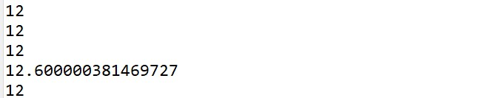

**7. Working with java.lang.Double**

**a.** Explore the [Java API documentation for java.lang.Double](https://docs.oracle.com/javase/8/docs/api/java/lang/Double.html) and observe its modifiers and super types.

**b.** Write a program to test how many bytes are used to represent a double value using the BYTES field. (Hint: Use Double.BYTES).

**package org.example.demo;**

**public class Assignment2_7_1 {**

**public static void main(String[] args) {**

**// TODO Auto-generated method stub**

**System.*out*.println(Double.*BYTES*);**

**}**

**}**

**Output –**



**c.** Write a program to find the minimum and maximum values of double using the MIN_VALUE and MAX_VALUE fields. (Hint: Use Double.MIN_VALUE and Double.MAX_VALUE).

**package org.example.demo;**

**public class Assignment2_7_2 {**

**public static void main(String[] args) {**

**// TODO Auto-generated method stub**

**System.*out*.println(Double.*MIN_VALUE*);**

**System.*out*.println(Double.*MAX_VALUE*);**

**}**

**}**

**Output –**



**d.** Declare a method-local variable number of type double with some value and convert it to a String using the toString method. (Hint: Use Double.toString(double)).

**package org.example.demo;**

**public class Assignment2_7_3 {**

**public static void main(String[] args) {**

**// TODO Auto-generated method stub**

**double number = 23.45;**

**String strnumber = Double.*toString*(number);**

**System.*out*.println(strnumber);**

**}**

**}**

**Output –**



**e.** Declare a method-local variable strNumber of type String with some value and convert it to a double value using the parseDouble method. (Hint: Use Double.parseDouble(String)).

**package org.example.demo;**

**public class Assignment2_7_4 {**

**public static void main(String[] args) {**

**// TODO Auto-generated method stub**

**String strnumber = "23.45";**

**double number = Double.*parseDouble*(strnumber);**

**System.*out*.println(number);**

**}**

**}**

**Output –**

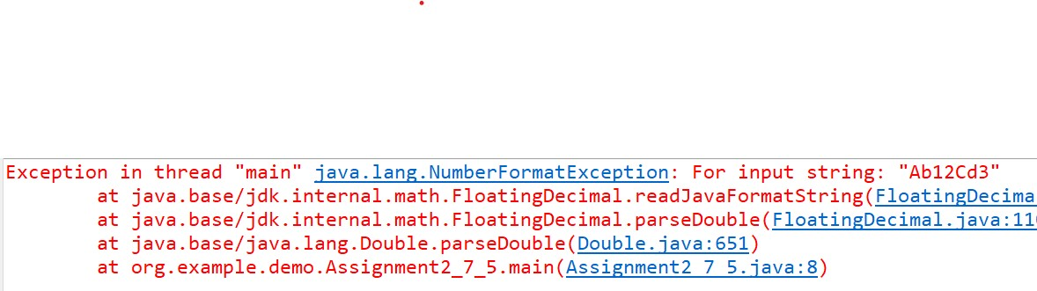

**f.** Declare a method-local variable strNumber of type String with the value "Ab12Cd3" and attempt to convert it to a double value. (Hint: parseDouble method will throw a NumberFormatException).

**package org.example.demo;**

**public class Assignment2_7_5 {**

**public static void main(String[] args) {**

**// TODO Auto-generated method stub**

**String strnumber = "Ab12Cd3";**

**System.*out*.println(Double.*parseDouble*(strnumber));**

**}**

**}**

**Output –**



**g.** Declare a method-local variable number of type double with some value and convert it to the corresponding wrapper class using Double.valueOf(). (Hint: Use Double.valueOf(double)).

**package org.example.demo;**

**public class Assignment2_7_6 {**

**public static void main(String[] args) {**

**// TODO Auto-generated method stub**

**double number = 123.456;**

**Double m = Double.*valueOf*(number);**

**System.*out*.println(m);**

**}**

**}**

**Output –**



**h.** Declare a method-local variable strNumber of type String with some double value and convert it to the corresponding wrapper class using Double.valueOf(). (Hint: Use Double.valueOf(String)).

**package org.example.demo;**

**public class Assignment2_7_7 {**

**public static void main(String[] args) {**

**// TODO Auto-generated method stub**

**String strnumber = "123.54";**

**Double number = Double.*valueOf*(strnumber);**

**System.*out*.println(number);**

**}**

**}**

**Output –**



**i.** Declare two double variables with values 112.3 and 984.5, and add them using a method from the Double class. (Hint: Use Double.sum(double, double)).

**package org.example.demo;**

**public class Assignment2_7_8 {**

**public static void main(String[] args) {**

**// TODO Auto-generated method stub**

**double num1 = 112.3;**

**double num2 = 984.5;**

**System.*out*.println(Double.*sum*(num1, num2));**

**}**

**}**

**Output –**



**j.** Declare two double variables with values 112.2 and 556.6, and find the minimum and maximum values using the Double class. (Hint: Use Double.min(double, double) and Double.max(double, double)).

**package org.example.demo;**

**public class Assignment2_7_9 {**

**public static void main(String[] args) {**

**// TODO Auto-generated method stub**

**double num1 = 112.3;**

**double num2 = 984.5;**

**System.*out*.println(Double.*min*(num1, num2));**

**System.*out*.println(Double.*max*(num1, num2));**

**}**

**}**

**Output –**



**k.** Declare a double variable with the value -25.0. Find the square root of this value. (Hint: Use Math.sqrt() method).

**package org.example.demo;**

**public class Assignment2_7_10 {**

**public static void main(String[] args) {**

**// TODO Auto-generated method stub**

**double num1 = -0.25;**

**System.*out*.println(Math.*sqrt*(num1));**

**}**

**}**

**Output –**



**l.** Declare two double variables with the same value, 0.0, and divide them. (Hint: Observe the result and any special floating-point behavior).

**package org.example.demo;**

**public class Assignment2_7_11 {**

**public static void main(String[] args) {**

**// TODO Auto-generated method stub**

**double num1 = 0.0;**

**double num2= 0.0;**

**double result = num1 / num2;**

**System.*out*.println(result);**

**}**

**}**

**Output –**



**m.** Experiment with converting a double value into other primitive types or vice versa and observe the results.

**package org.example.demo;**

**public class Assignment2_7_12 {**

**public static void main(String[] args) {**

**// TODO Auto-generated method stub**

**double num = 23.45;**

**byte b = (byte) num;**

**System.*out*.println(b);**

**short s = (short) num;**

**System.*out*.println(s);**

**int i = (int) num;**

**System.*out*.println(i);**

**float f = (float) num;**

**System.*out*.println(f);**

**long m = (long) num;**

**System.*out*.println(m);**

**}**

**}**

**Output –**

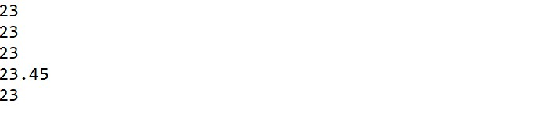

**8. Conversion between Primitive Types and Strings**

Initialize a variable of each primitive type with a user-defined value and convert it into String:

* + First, use the toString method of the corresponding wrapper class. (e.g., Integer.toString()).
  + Then, use the valueOf method of the String class. (e.g., String.valueOf()).

**package org.example.demo;**

**public class Assignment2_8 {**

**public static void main(String[] args) {**

**// TODO Auto-generated method stub**

**byte b = 12;**

**short s = 123;**

**int i = 1234;**

**float f = 123.34f;**

**long l = 12345;**

**double d = 2321.34;**

**boolean bool = true;**

**System.*out*.println(Byte.*toString*(b));**

**System.*out*.println(Short.*toString*(s));**

**System.*out*.println(Integer.*toString*(i));**

**System.*out*.println(Float.*toString*(f));**

**System.*out*.println(Long.*toString*(l));**

**System.*out*.println(Double.*toString*(d));**

**System.*out*.println(Boolean.*toString*(bool));**

**System.*out*.println("\n\n");**

**System.*out*.println(String.*valueOf*(b));**

**System.*out*.println(String.*valueOf*(s));**

**System.*out*.println(String.*valueOf*(i));**

**System.*out*.println(String.*valueOf*(f));**

**System.*out*.println(String.*valueOf*(l));**

**System.*out*.println(String.*valueOf*(d));**

**System.*out*.println(String.*valueOf*(bool));**

**}**

**}**

**Output –**

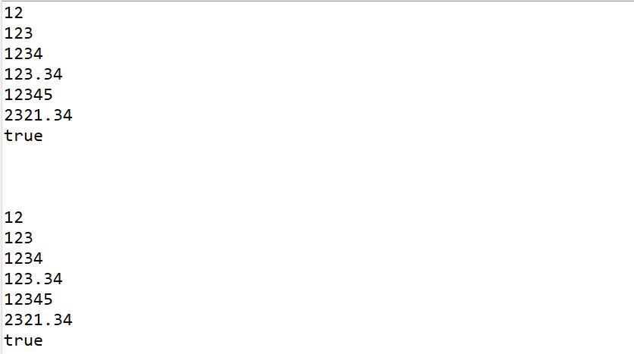

**9. Default Values of Primitive Types**

Declare variables of each primitive type as fields of a class and check their default values. (Note: Default values depend on whether the variables are instance variables or static variables).

**package org.example.demo;**

**public class Assignment2_9 {**

**byte num1;**

**short num2;**

**int num3;**

**float num4;**

**long num5;**

**double num6;**

**char num7;**

**boolean num8;**

**public static void main(String[] args) {**

**// TODO Auto-generated method stub**

**Assignment2_9 values = new Assignment2_9();**

**System.*out*.println("Byte Value : "+values.num1);**

**System.*out*.println("Short Value : "+values.num2);**

**System.*out*.println("Integer Value : "+values.num3);**

**System.*out*.println("Float Value : "+values.num4);**

**System.*out*.println("Long Value : "+values.num5);**

**System.*out*.println("Double Value : "+values.num6);**

**System.*out*.println("Character Value : "+values.num7);**

**System.*out*.println("Boolean Value : "+values.num8);**

**}**

**}**

**Output -**

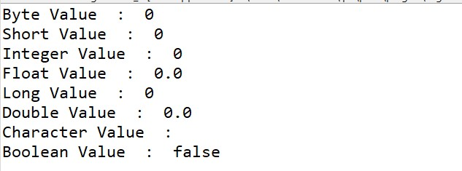

**10. Arithmetic Operations with Command Line Input**

Write a program that accepts two integers and an arithmetic operator (+, -, *, /) from the command line. Perform the specified arithmetic operation based on the operator provided. (Hint: Use switch-case for operations).

**package org.example.demo;**

**import java.util.Scanner;**

**public class Assignment2_10 {**

**public static int *result*=0;**

**public static void main(String args[]) {**

**Scanner sc = new Scanner(System.*in*);**

**System.*out*.println("Enter num1: ");**

**int num1 = sc.nextInt();**

**System.*out*.println("Enter num2: ");**

**int num2 = sc.nextInt();**

**System.*out*.println("ENTER CHOICE : ");**

**System.*out*.println("Enter operation (+,-,*,/) : ");**

**char ch=sc.next().charAt(0);**

**switch (ch) {**

**case '+':**

***result* = num1+num2;**

**break;**

**case '-':**

***result* = num1-num2;**

**break;**

**case '*':**

***result* = num1 * num2;**

**break;**

**case '/':**

***result* = num1 / num2;**

**break;**

**default:**

**System.*out*.println("Invalid entry");**

**break;**

**}**

**System.*out*.println("The result of "+num1+" and "+num2+" is :" +*result*);**

**sc.close();**

**}**

**}**

**Output –**

